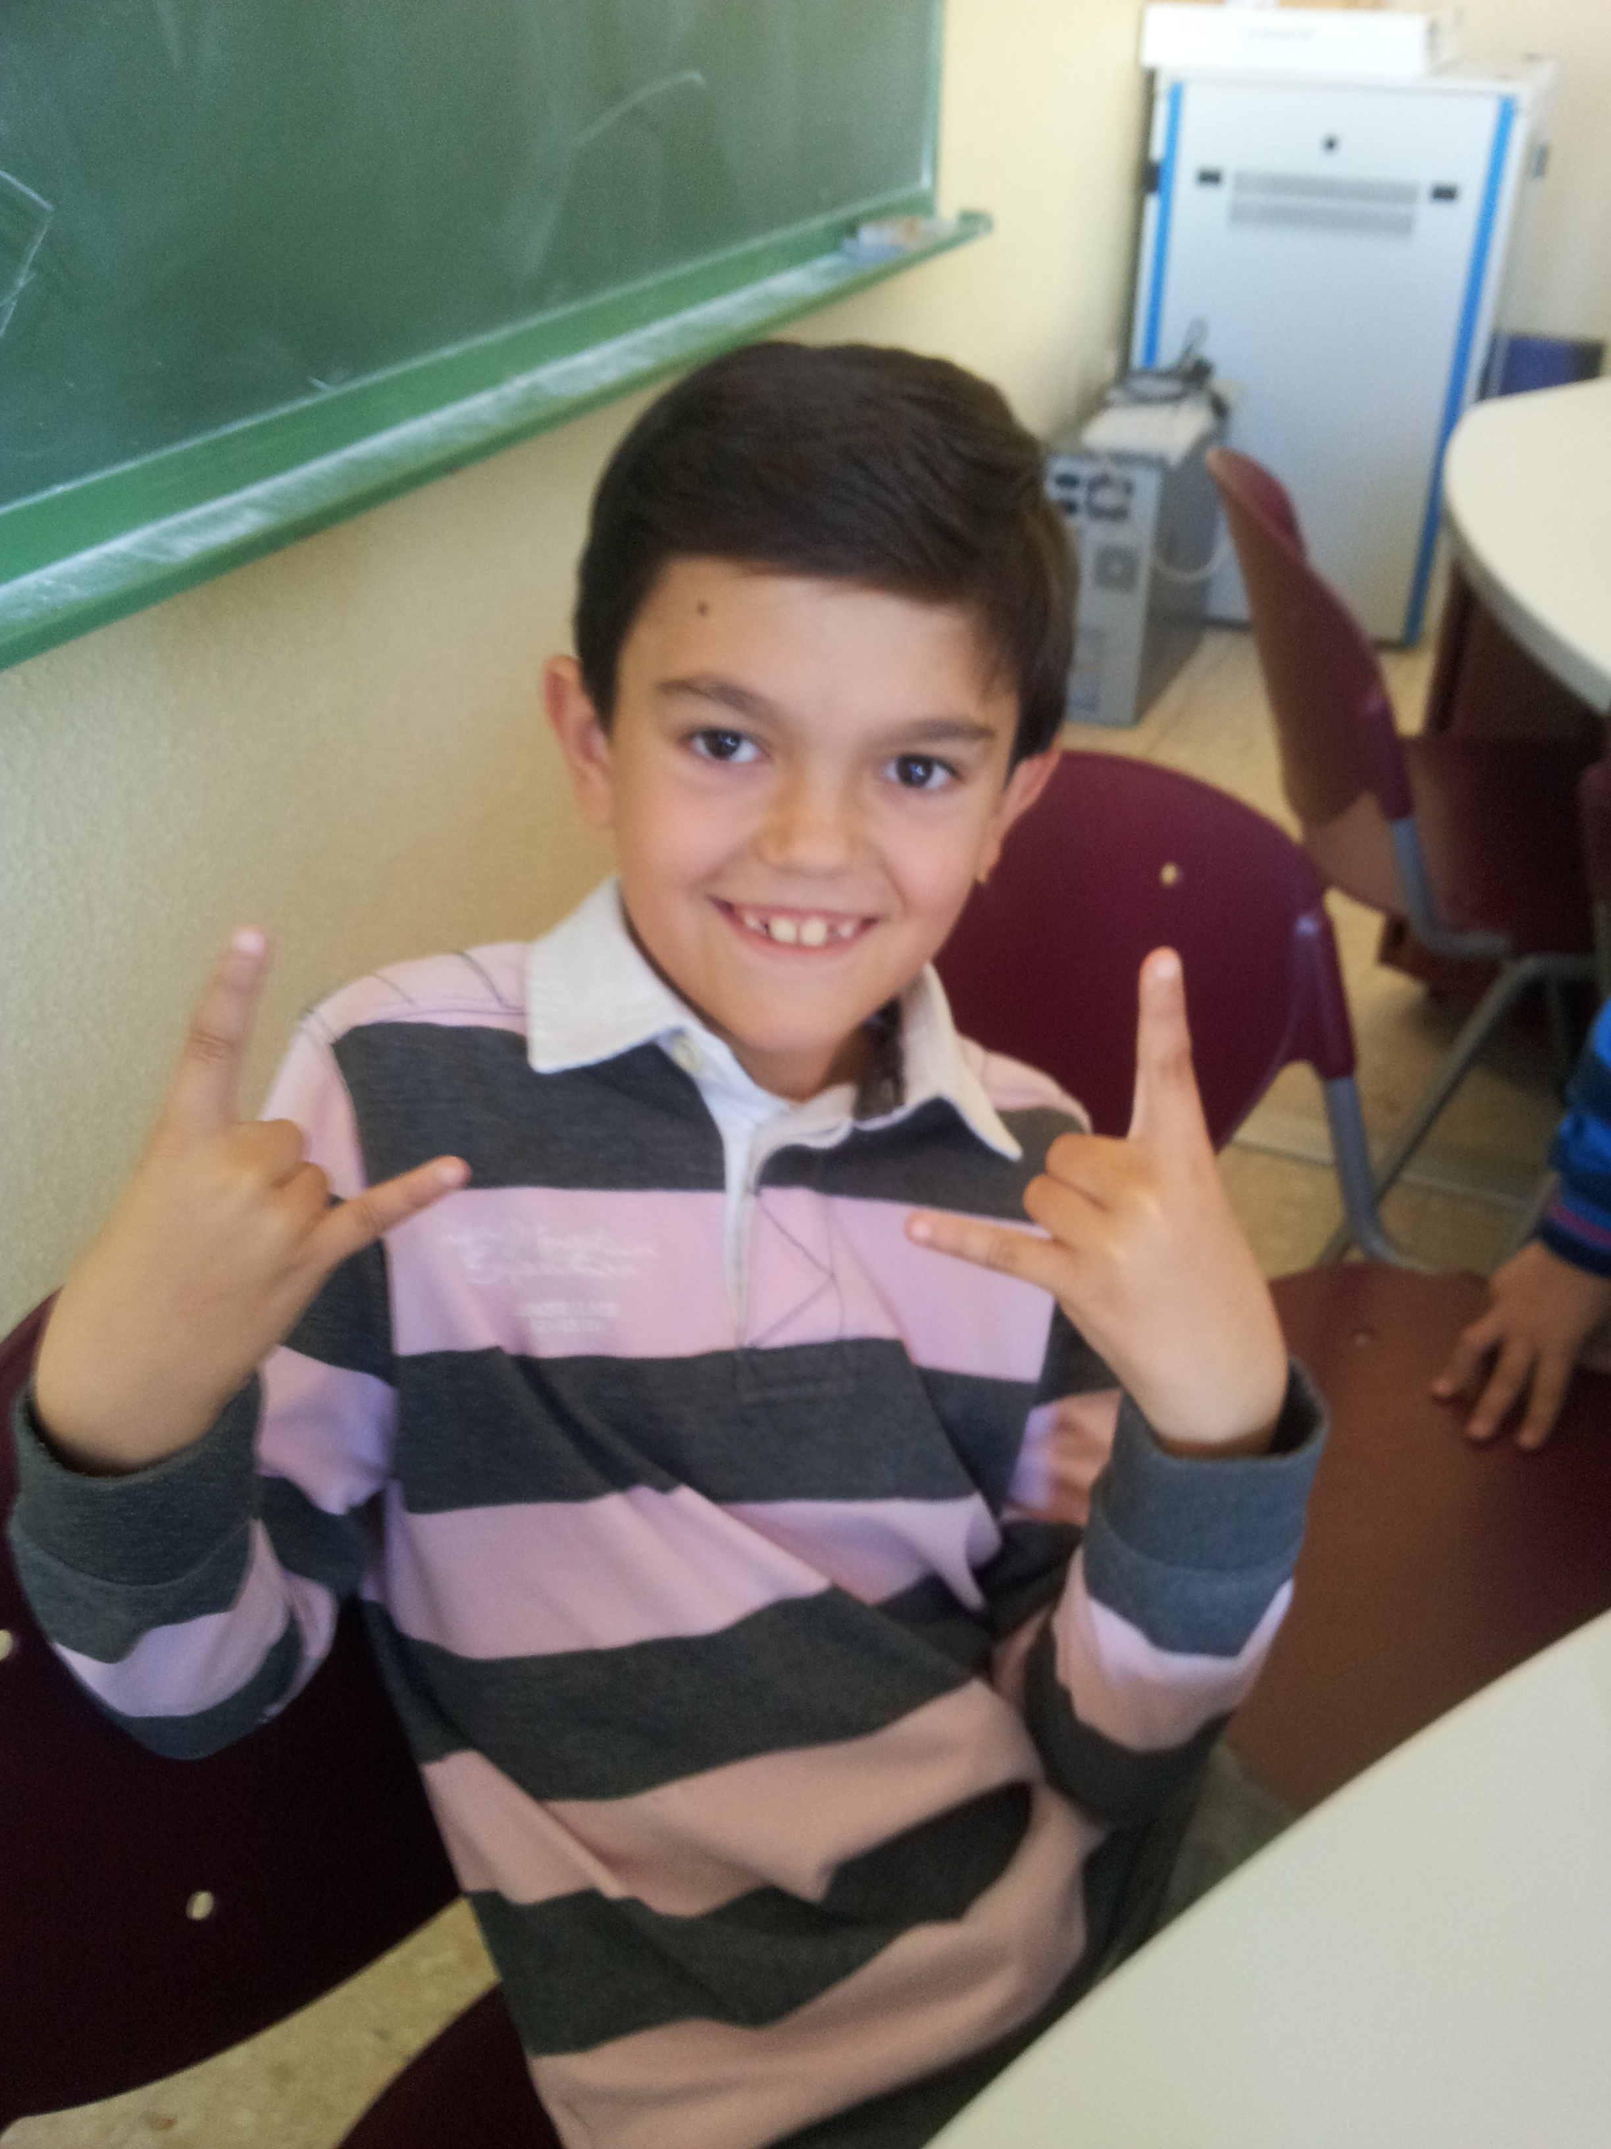
Hello

My name is Samuel
I´m 9 years old.
I´m from Spain.
I live in Socuèllamos.
I go to school by car.
Today is Friday.
My school´s name is Gerardo Martinez.
There are twenty-four students in my classroom.
My English teacher Is Carlos.
My best friend is Daniel.

